Leave Your Leaves Lesson 4
Would you Be-Leave It? Student Worksheet

- Generally, we think of leaves as what plants use for photosynthesis. What function does photosynthesis serve?

- Which organelle is the site of photosynthesis?

- Make a simple sketch of this organelle and label the following parts: stroma, thylakoids, lumen, granum, inner membrane, outer membrane.

- How does this organelle work with other organelles in plant cells to help the plant survive?

- Over time, though, plant species, have adapted so that the shapes of their leaves help them to survive in their particular environments. Look at the pictures of the various plant species below, and answer the questions about how their leaf shape helps them to thrive in their environment.

Plant Species | Describe the Shape of the Leaf | Climate(s) Where These Plants are Native? | How Leaf Adaptation  Helps Species to Survive
Virginia pine

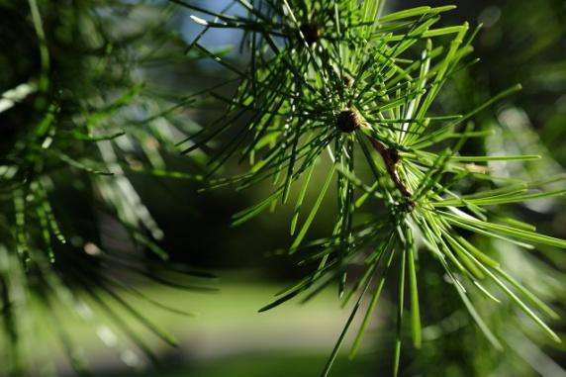

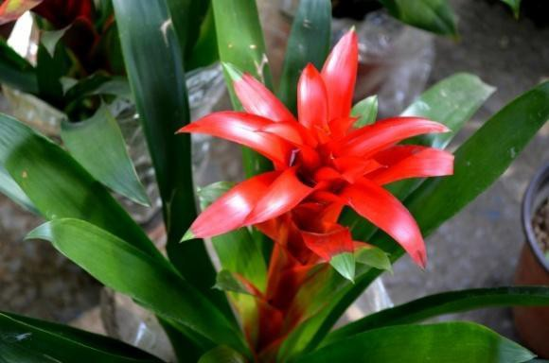
Guzmania Bromeliad
Venus flytrap

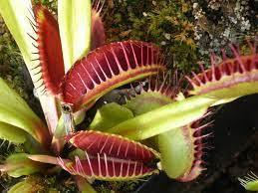

Beech

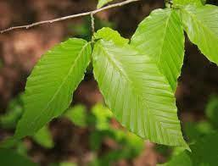

Saguaro cactus

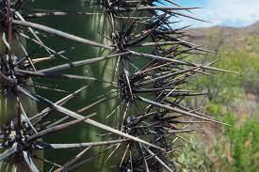

- What evolutionary advantage might there be for a plant to

  - be evergreen?
  - be deciduous?

- Pick one of the leaf times from above, and describe how it could have evolved. Think about what you know about natural selection.

